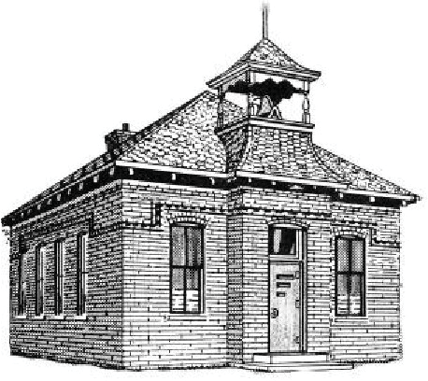
WEST RIVERSIDE SCHOOL REGISTRATION 2021

If your family is sending multiple students please include all students on one registration form. The cost is $75/per student or $65/per student with a family member that is a current member of the Isanti County Historical Society. You can become a member on our website. There is a $5 online registration fee making it $80 per student or $70 per student.

Student(s) Name:

Grade(s) Completed:
First Session Choice:
Second Session Choice:
*Please note that all sessions are first come first serve. We will accommodate the best we can but the class needs to have a balance of grade levels. You will be notified regarding your session to confirm. Payment is due at time of registration.

Parent(s)/Guardian(s) Name:
Address:
Telephone Number:
Email Address:
Additional Contact:
Additional Contact:

Make checks payable to: West Riverside School

Mail completed registration and checks to:

Isanti County Historical Society
Attn: Kay Rodrigue

33525 Flanders St NE Cambridge, MN 55008

